**The Impact of Digital and Spatial Technologies on Data Access, Use, and Communication**

Student Name

Date

**The Impact of Digital and Spatial Technologies on Data Access, Use, and Communication**

Introduction

The rapid evolution of spatial and digital technology has reshaped the way data is shared, accessed, and utilized. Technologies such as Geographic Information Systems (GIS), remote sensing, artificial intelligence (AI), the Internet of Things (IoT), and cloud computing are revolutionizing the way individuals and organizations interact with data. These technologies enable raw data to be transformed into meaningful insights through automation, visualization, and real-time interaction, allowing decision-making to be more responsive and evidence-based across a wide range of industries.

Data Access: More Availability and Interoperability

Digital and spatial technology have revolutionized access to data by enabling openness, decentralization, and instant access. Cloud-based platforms, such as Google Earth Engine and Amazon Web Services (AWS), enable elastic access to global datasets without requiring high-performance computing infrastructure (Hiriyannaiah et al., 2023). On the other hand, APIs, open-source repositories, and cell phone data collection tools supplement user-driven access and personalizability (Gaur & Garg, 2023). These technologies are particularly beneficial during emergencies. Geospatial information, for example, during the 2023 Türkiye–Syria earthquake, enabled rescue teams to assess damaged areas within hours using freely available satellite data and AI-based image classifiers (Reilley, 2024).

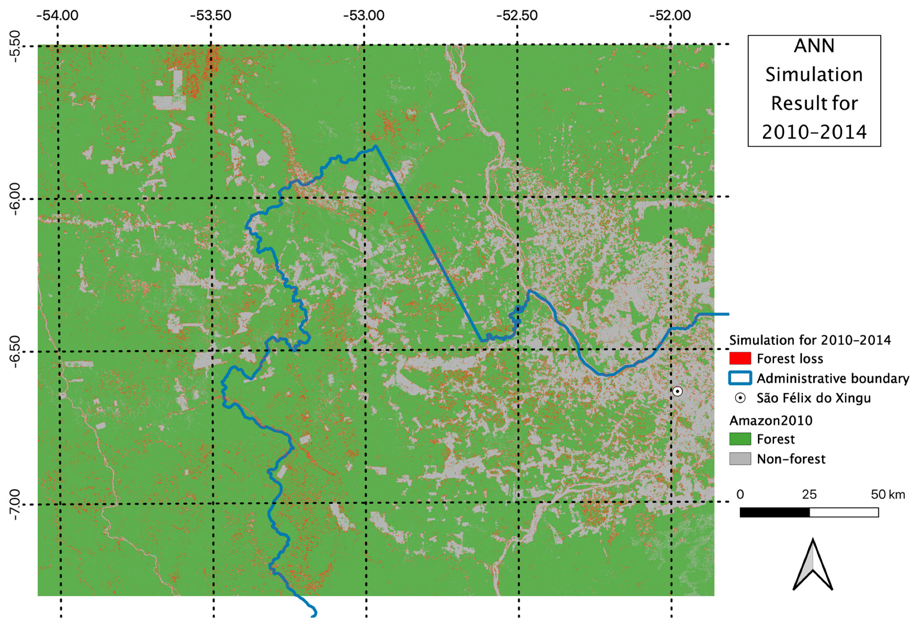*Figure 1: Interface of Google Earth Engine showing deforestation mapping in the Amazon Basin.*

Use of Data: From Descriptive to Predictive Intelligence

Geographic and digital technology shifted the paradigm of analysis from descriptive statistics to predictive and prescriptive analytics. GIS now supports multi-layer spatial modeling, and AI supplements data interpretation through pattern recognition, anomaly detection, and real-time forecasting (Del Rosso et al., 2021). In smart cities, for instance, digital twins mimic city systems in the physical world to maximize energy management, transport logistics, and land-use planning (Visvizi & Godlewska-Majkowska, 2025). Applications in the environment include monitoring climate change effects, predicting wildfire spread, and hydrological hazard mapping based on geospatial considerations.

| **Feature** | **Traditional Approach** | **Digital/Spatial Technology Approach** |
| --- | --- | --- |
| Data Collection | Manual surveys, reports | Remote sensing, drones, IoT |
| Processing Time | Slow and manual | Automated and real-time |
| Visual Output | Paper maps, static charts | Interactive 3D models, dashboards |
| Analytical Power | Descriptive only | Predictive and machine learning-based |

*Table 1: Comparison of Traditional and Digital Approaches to Spatial Data Analysis*

Data Communication: Public Engagement and Visualization

Data communication is also increasingly visual, interactive, and intuitive. Spatial dashboards and web-based story maps allow for complex geospatial data to be conveyed to a wider audience, including policymakers, local communities, and non-specialists (Jabbour & Babiarz, 2023). During the COVID-19 pandemic, global dashboards like those created by Johns Hopkins University provided interactive maps and charts that presented case counts and trends in a way that was clear and actionable (Grant, 2019). These tools facilitated transparency and allowed the public and governments to make informed decisions.

*Diagram 1: Lifecycle of Spatial-Digital Data*

Ethics and Equity Concerns

Even though they are beneficial, digital and spatial technologies also have ethical and equity issues. Good-quality spatial data remains inaccessible in the majority of low-income countries due to poor digital infrastructure, in addition to strict data policies (Kundu, 2022). Further, algorithmic biases in spatial prediction can increase system-wide inequalities, especially in policing, insurance, and housing (Gopal & Pitts, 2024). Surveillance concerns, ownership of data, and digital colonialism also emerge when globally headquartered institutions own data relevant to a locality in the absence of proper community involvement. Fair data governance and transparent algorithms, thus, are necessary to ensure that digital-spatial technologies serve everyone who is involved (Mobasheri, 2021).

Conclusion

Space and digital technologies have revolutionized access to, use of, and communication of data. They give power to users in different sectors through real-time access, advanced analytics, and interactive visualization. Yet, their application needs to be coupled with critical awareness of ethical considerations, inequality of data, and bias of algorithms. For maximum impact, the future technology advancements should be centered on inclusiveness, transparency, and capacity building in the underrepresented regions. The intersection of technology, information, and society demands not only technological ingenuity but also prudent stewardship.

**References**

Del Rosso, M. P., Sebastianelli, A., & Liberata Ullo, S. (2021). *Artificial intelligence applied to satellite-based remote sensing data for earth observation.* The Institution of Engineering and Technology. <https://search.ebscohost.com/login.aspx?direct=true&scope=site&db=nlebk&db=nlabk&AN=2999304>

Gaur, L., & Garg, P. K. (2023). *Emerging trends, techniques, and applications in geospatial data science.* IGI Global, Engineering Science Reference, an imprint of IGI Global. https://doi.org/10.4018/978-1-6684-7319-1

Gopal, S., & Pitts, J. (2024). *The FinTech Revolution : bridging geospatial data science, AI, and sustainability.* Springer. https://doi.org/10.1007/978-3-031-74418-1

Grant, R. (2019). *Data visualization : charts, maps, and interactive graphics*. CRC Press, Taylor & Francis Group. https://search.ebscohost.com/login.aspx?direct=true&scope=site&db=nlebk&db=nlabk&AN=1944722

Hiriyannaiah, S., Siddesh, G. M., & Srinivasa, K. G. (2023). *Cloud-based multi-modal information analytics : a hands-on approach (First edition).* CRC Press. <https://doi.org/10.1201/9781003215974>

Jabbour, A., & Babiarz, R. (2023). *Geospatial data, Information, and intelligence*. Artech House. <https://search.ebscohost.com/login.aspx?direct=true&scope=site&db=nlebk&db=nlabk&AN=3675081>

Kundu, S. N. (2022). *Geospatial data analytics and urban applications.* Springer. <https://doi.org/10.1007/978-981-16-7649-9>

Mobasheri, A. (2021). *Open source geospatial science for urban studies : the value of open geospatial data*. Springer. https://doi.org/10.1007/978-3-030-58232-6

Reilley, M. (2024). *The journalist’s toolbox : a guide to digital reporting and AI.* Routledge. <https://doi.org/10.4324/9781003431787>

Visvizi, A., & Godlewska-Majkowska, H. (2025). *Smart cities : lock-in, path-dependence, and non-linearity of digitalization and smartification.* Routledge. https://doi.org/10.1201/9781003415930